**DAILY ONLINE ACTIVITIES SUMMARY**

|  |  |  |  |  |  |  |  |  |
| --- | --- | --- | --- | --- | --- | --- | --- | --- |
| **Date:** | **11/07/2020** | | | | | **Name:** | **Lavanya D M** | |
| **Sem & Sec** | **4th & ‘A’** | | | | | **USN:** | **4al18cs041** | |
| **Online Test Summary** | | | | | | | | |
| **Subject** | | **----** | | | | | | |
| **Max. Marks** | | **----** | | **Score** | | | **-----** | |
| **Certification Course Summary** | | | | | | | | |
| **Course** | Java programming | | | | | | | |
| **Certificate Provider** | | | **Courseera** | | **Duration** | | | **20 hrs** |
| **Coding Challenges** | | | | | | | | |
| **Problem Statement:** 1)Write a Java program for Reversal algorithm for array rotation by 32)C++ program to Print Alphabet Triangle | | | | | | | | |
| **Status: Complied** | | | | | | | | |
| **Uploaded the report in Github** | | | | | **yes** | | | |
| **If yes Repository name** | | | | | <https://github.com/lavanyamurthi/lockdown-coding> | | | |
| **Uploaded the report in slack** | | | | | **yes** | | | |

Online Test Details: (Attach the snapshot and briefly write the report for the same)

No test conducted

Certification Course Details: (Attach the snapshot and briefly write the report for the same)

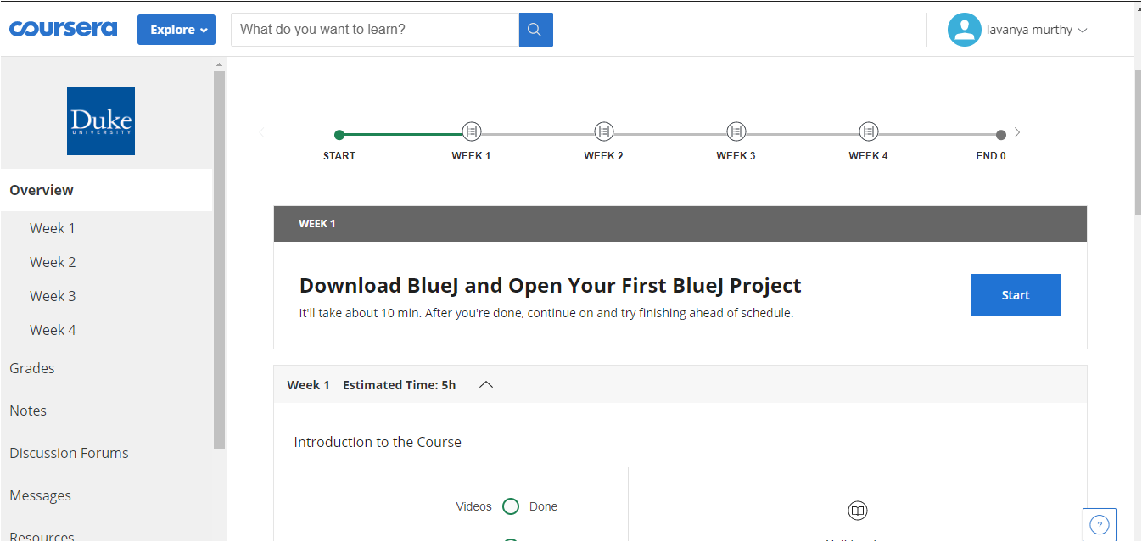

Coding Challenges Details: (Attach the snapshot and briefly write the report for the same)

# **Problem 1 :** Write a Java program for Reversal algorithm for array rotation by 3

Given an array a[], array size n and d the number of index to be rotated task is to write a function rotate(arr[],d,n) that rotates arr[] of size n by d elements.

Example  
Input:  
n= 6  
arr[]= {1,2,3,4,5,6}  
d=3 (specific)  
Output: arr[]= {4,5,6,1,2,3}

# 

|  |
| --- |
|  |
|  |  |

# **Problem 2:**C++ program to Print Alphabet Triangle

